1 Oct update — ILA against the exact optimum, and a refinement that closes the gap
Jaeyun Ree · 1 October 2026 · follows the measurement Eunus set on 18 September. Spatial problem only (time constraints off), which is the scope of the exact solver.

In short
- The gap does not widen when AVs are scarce — it closes. At AV:PV = 1 % on the real M1 corridor, ILA is exactly optimal in all twelve 5-minute windows.
- Difficulty is an inverted U in the ratio. Both heuristics are near-optimal at 1–5 % and again at 100 %; the hard regime is 20–40 %, where they sit at about 94 % of the optimum and there is most to tow.
- A refinement step closes most of the remaining gap. Over 50 proven-optimal M1 instances it averages 100.00 % of the optimum; over 97 synthetic instances, 99.74 %. Median 0.4 s per instance.
- The refinement is not specific to ILA. It lifts greedy by as much, so the contribution is the refinement, not the starting heuristic.

1. What Eunus asked, and the answer
The question was whether ILA falls further behind the optimum when AVs are scarce, because a myopic choice then costs a longer tow. Measured at 1, 2, 5, 10 and 20 %, with 10 seeds per synthetic cell and 12 five-minute windows per M1 point:
AV : PV | 1 % | 2 % | 5 % | 10 % | 20 %
ILA, % of optimum — synthetic (PV = 100) | 99.2 | 99.5 | 99.4 | 99.1 | 97.6
ILA, % of optimum — M1 corridor | 100.0 | 99.7 | 99.7 | 99.0 | 99.3
Share of PV distance the optimum tows | 2 % | 5 % | 11 % | 22 % | 42 %
The hypothesis is not supported: scarcity makes the problem easier for the heuristic, because there is little to tow and therefore little to choose between. Extending the sweep upward shows where it is actually hard:
AV : PV | 1–5 % | 10 % | 20 % | 40 % | 60 % | 100 %
greedy, % of optimum | 98.7 | 97.9 | 95.3 | 93.6 | 95.0 | 98.4
ILA, % of optimum | 98.8 | 98.0 | 95.9 | 93.9 | 96.8 | 99.1
Share of PV distance towed | 5–9 % | 22 % | 44 % | 67 % | 98 % | 99.9 %
At the top end the AVs are so plentiful that essentially all PV distance is towed anyway, so again the choice hardly matters. The hard regime is the middle, 20–40 % — much to tow, not quite enough capacity.
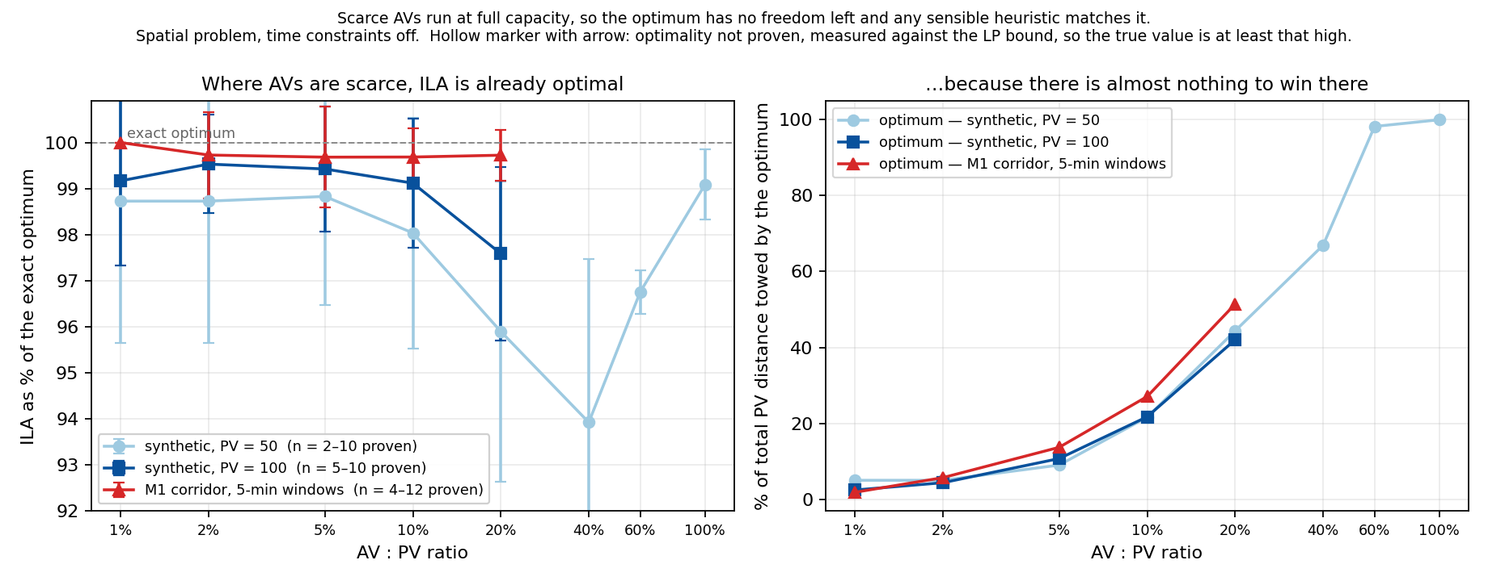
Figure 1. ILA against the exact optimum (left) and how much there is to win (right). Hollow marker with arrow: optimality not proven, measured against the LP bound, so the true value is at least that high.

2. Why ILA loses — measured, not guessed
On one instance at 92.2 % of the optimum (10 AVs, 50 PVs):
 | ILA | optimum
towing segments | 21 | 53
mean segment length | 36.0 | 15.5
PVs served | 21 | 37
segments cut short of the full shared overlap | 0 by construction | 43 of 53
ILA always commits the whole shared overlap, so it fills the AVs with a few long tows. The optimum cuts tows short and hands the freed capacity to other PVs. ILA leaves 9.8 % of the AV capacity idle, but every idle stretch is shorter than the minimum towing distance, so nothing can be inserted into it.
The loss is capacity filled with the wrong segments, not capacity left unused. This is why a first attempt that only inserted and extended gained nothing and finished in 0.00 s: by construction there was nothing to insert.

3. The refinement
Remove every assignment that a subset of AVs holds inside a random stretch of road, rebuild greedily, and keep the result only if the total improved. Repeat.
The rebuild must be randomised. Rebuilding longest-first repeats ILA's own bias and gains 0.7 pp. Sampling a candidate segment with probability proportional to its length gains 6.7 pp on the same instance — it finds the many-short-segments structure the optimum uses. Rebuilt segments may be cut short, which is the freedom ILA never uses.
 | ILA | ILA + refinement | exactly optimal
Synthetic, 97 proven-optimal instances | 98.46 % | 99.74 % | 70 / 97
M1 corridor, 50 proven-optimal instances | 99.77 % | 100.00 % | 50 / 50
Synthetic at 20 % / 40 % | 95.9 / 93.9 % | 99.5 / 97.7 % | —

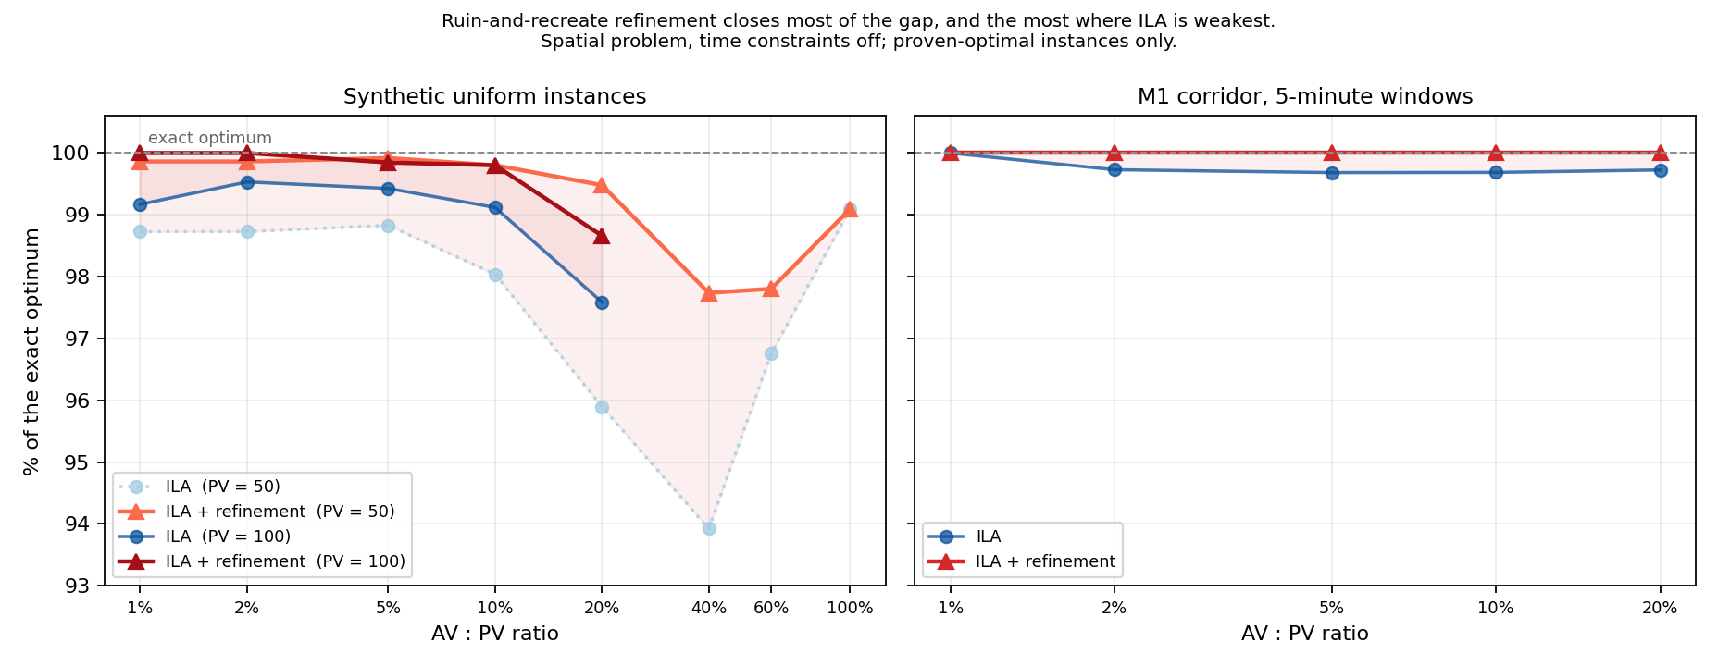
Figure 2. The shaded band is what the refinement recovers. It is widest at 20–40 %, exactly where the heuristics are weakest.
Honest caveat on the claim. The same step lifts greedy by as much (93.96 → 98.91 % at ratio 20 %, and ahead of ILA + refinement at two of the three ratios tested). So the contribution is the refinement, not ILA. That seems a cleaner position than the paper's current one: the starting heuristic stops being the claim.
Budget limitation. Above 40 % the gain falls away because the prototype runs out of time, not because there is nothing left to find: it rescans every AV–PV pair for each insertion, so one iteration at 50 AVs costs about 100× one at 5 AVs. At ratio 100 % the 15 s budget buys too few iterations to accept anything. Incremental candidate updates would fix this; it has not been done.

4. What this could mean for the paper
The paper could become: the problem; an exact formulation; a measurement of how far existing heuristics sit from the optimum and why; and a refinement that closes that gap to approximately zero on real-corridor instances. The diagnosis and the fix are linked — the fix follows from the measurement rather than from trial and error.
Two limits to settle. (a) The MILP covers the spatial problem only, so there is still no optimum baseline with time constraints on — which is where ILA's advantage over greedy lived. Extending it is non-linear, because towing changes later arrival times. (b) The M1 demand is still the randomTrips placeholder; partial calibration against DTP detector counts is a 2–3 day job once approved.

5. What I would like to decide with you
- Framing. Is “problem + exact benchmark + refinement” the right contribution, with the starting heuristic demoted?
- The temporal baseline. Do we attempt an exact formulation with time constraints, or state its absence as a limitation and evaluate the refinement on the spatial problem only?
- Demand calibration. Proceed with the partial TIRTL calibration for the M1 scenario?
- Scale. The MILP proves optimality up to roughly 20 AVs / 200 PVs. Is that enough for the exact-comparison section, with larger instances compared against the LP bound?

Code: core/refine.py, milp/lowratio_sweep.py, milp/m1_lowratio.py, milp/refine_eval.py, analysis/plot_lowratio.py, analysis/plot_refine.py. Full notes in NOTES.md (2026-10-01).

